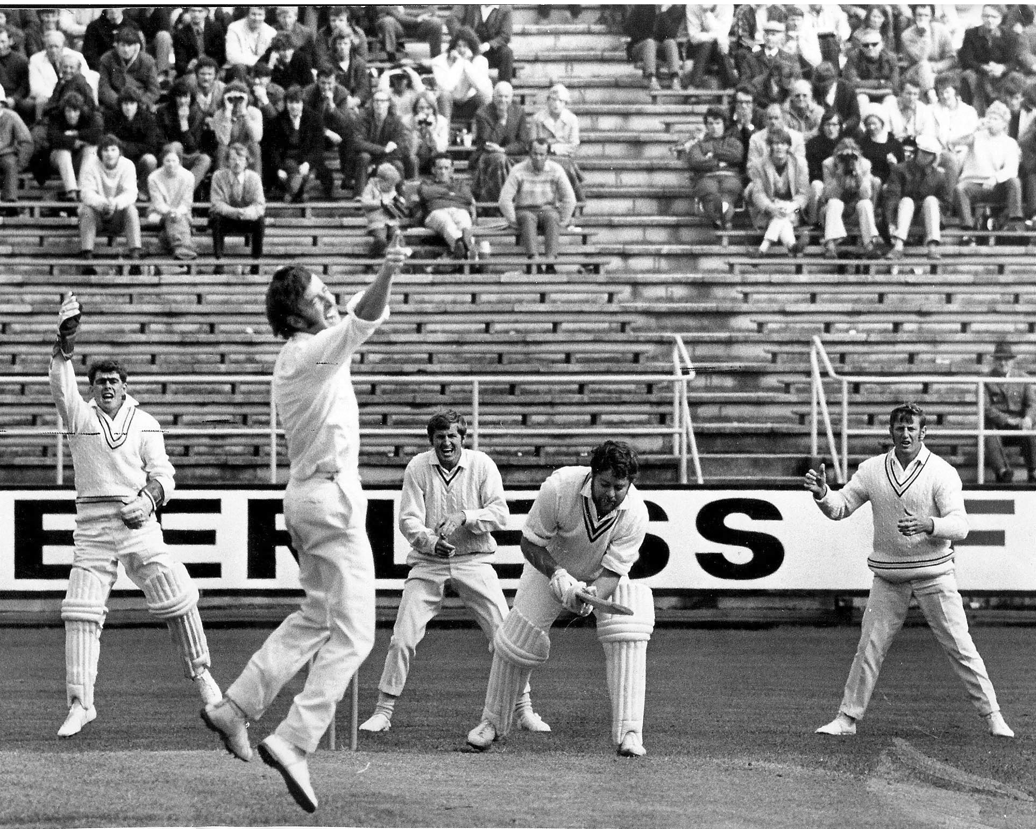

**David Trist appeals unsuccessfully for lbw against Wayne Blair. 27 December 1971 Carisbrook**

**Brian Isherwood wicketkeeper, Maurice Ryan and David Stead slip field**

**Canterbury 163/8 declared and 123/8 declared Otago 161/4 declared and 130/4. Otago won by six wickets. No play on day one**